The Factors which caused by the TEC line jump points

Name: Zijun Liu

Course: COEN1550

Date: Mar 3th

Instuctor: Beth Mayer

**Abstract**

From this semester, I have a chance to work with graduate mentor to do a research, I’m really excited about that. It’s a huge improvement for me to do the and it’s helpful for me to achieve master degree. I work with Brian Breitsch in GNSS lab and work in aerospace area to determine the TEC line. As for why I work in this topic, because it’s basic for aerospace area and it can be used for machine learning to collect the data and analyze why it causes these jump points.

**Introduction**

Before starting this research, I’m a little nervous about what to do in the research. It’s hard to use the knowledge learned in the lecture into real world question. I’m willing to deal with real world question, because I’m not good at abstract question. I learned some basic concept like linear regression, logistic regression and Scikit Python library. After some time, we work on plot the point for the TEC line and start to think about what to cause these data.

**Question**

As for this research topic, we’re going to determine what are the factors that the TEC line jump points occurring. Here is a simple TEC line for Sep 1st, 2018. 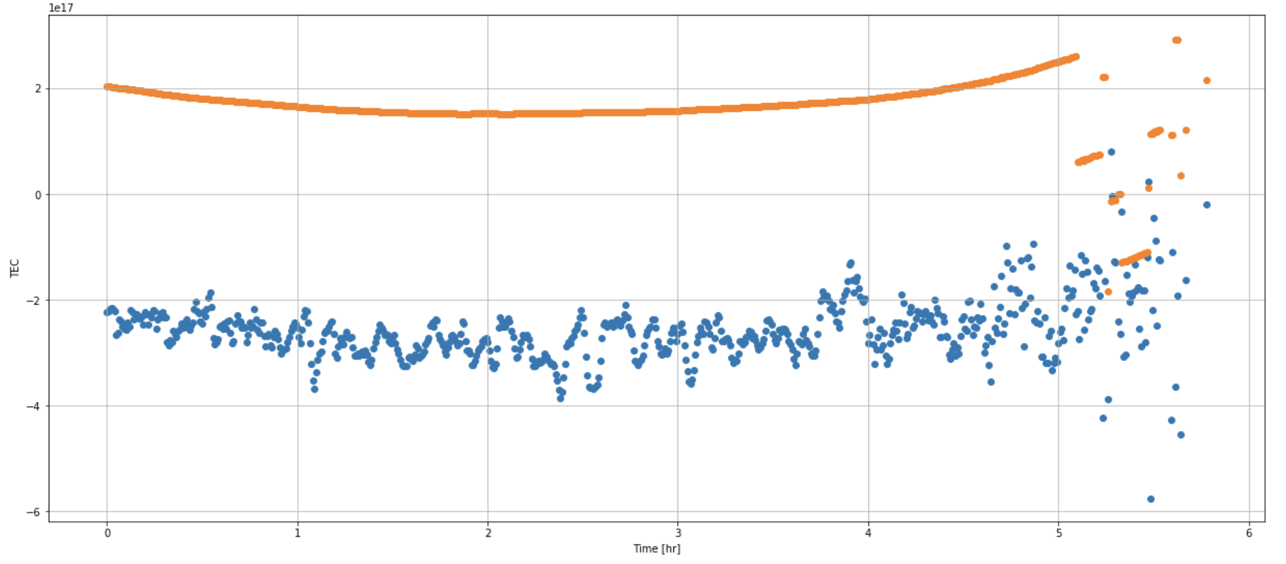

The orange jump point is the topic that we want to figure it out. TEC means that Total Electron Content and total electron content and the number of electrons in a tube of 1 meter square cross section extending from the receiver to the satellite.. In order to get the TEC line, we are going to difference between Pseudorange for L1 and L2. L1 and L2 means the dual frequency. (I will carefully explain that after I finish it and I will discuss it with me mentor).

**Equations:**

In this research topic, we use several equation, which is used for aerospace area like below: (I will explain it and tell yours what useful for each equation)



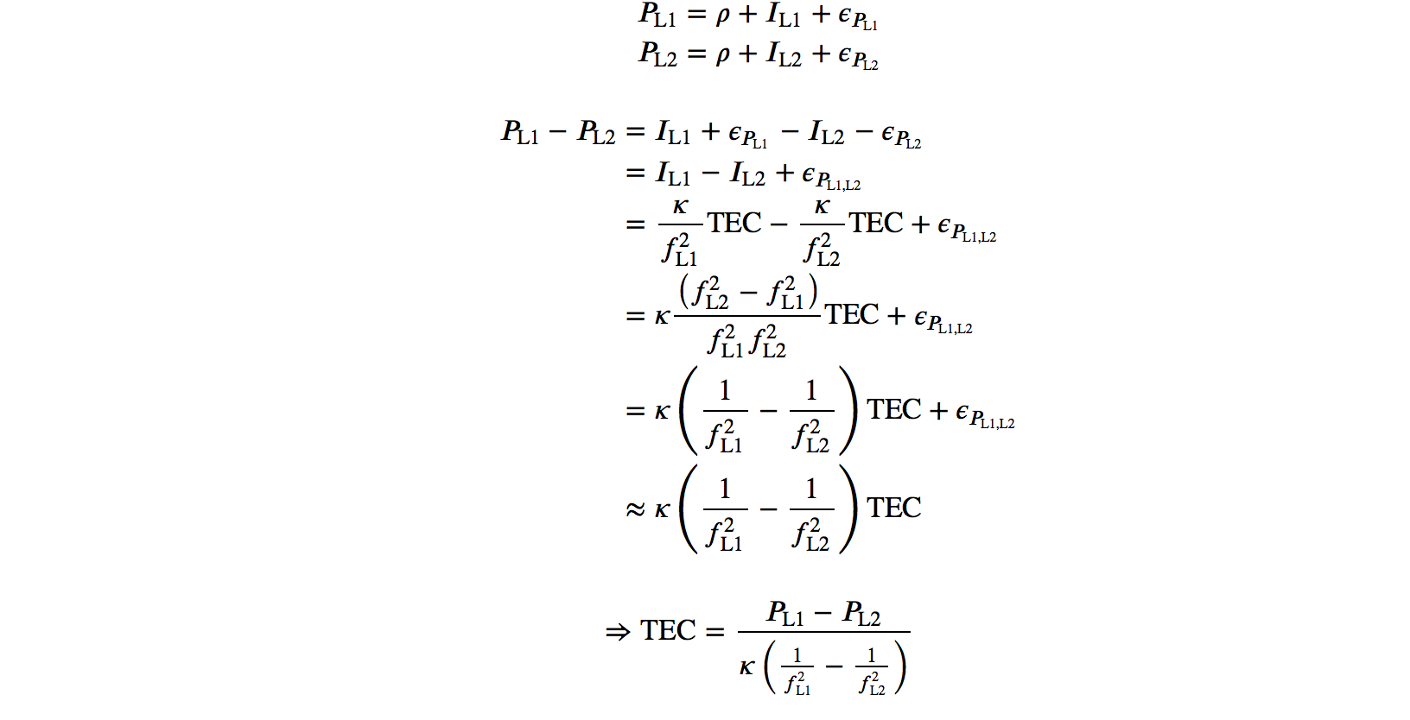

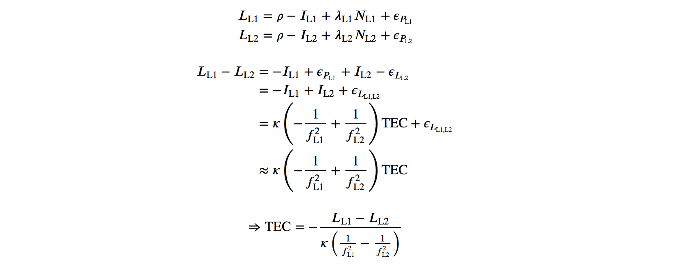

**Method**

For these research project, it has been cut by four parts.

First, I would learn how to plot the TEC line data. I would like to use the difference between dual frequency signal from satellite and use the equation above to get the TEC line.

Second, I’m working on auto download the data file, which contains the dual frequency signal, and auto draw the TEC line. Because I have to see many data, and then I can think about what’s the reason caused these and I will figure it out later.

Third, I’m going to working on determine the difference between each jump points. Some picture have jump point at the end of the graph, some picture have several constant line, but it has jump point between each line and so on. so I have to know the difference between each jump point.

Finally, I will use machine learning to collect the data and know what’s reason caused by these jump point.

**Analysis**

Currently, I guess some of the jump points because other satellite blocks the signal. Or the satellite almost reaches another earth, so the receive can’t receive the signal, that’s why it has jump point in the end of the picture. (I will use machine learning to figure it out later).